CS 514

Applied Artificial Intelligence

Project 1

FITNESS STAR

A PERSONAL FITNESS ASSISTANT EXPERT SYSTEM

INDEX

|  |  |
| --- | --- |
| Topic | Page number |
| Abstract | 3 |
| Features of the Fitness Star Expert System | 3 |
| Rules and Descriptions | 4 |
| Usage Manual | 6 |
| Sample runs (Run #1, #2 and #3) | 7 |
| Test cases | 10 |

***Note:*** *Suitable links have been provided for additional information wherever necessary in RULES and DESCRIPTION.*

# Abstract:

Fitness Star is a rule based expert system built on JESS that is designed to take certain health related parameters from the user and infer certain vital parameters and makes recommendations to the user of the system. The system advices user his workout and food intake plans based on the person’s age, gender, weight, and height and resting heart rate. The system is also capable of diagnosing chances of diabetes and other coronary heart conditions based on blood pressure levels, sugar levels and sleep patterns.

# Features:

1. The system can calculate parameters like Body Mass Index and Basal Metabolic Rate of the individual.
2. The system calculates Body Fat percentage and Lean Body Mass.
3. The system can classify the individual into different obesity fitness levels.
4. The system also computes the current daily food intake in calories and recommends to increase or decrease food intake depending on certain vital parameters.
5. The system also calculates the number of calories to be burnt per day for individuals who are above the normal weight.
6. The system also gives you of a rough estimate of number of days it will take to reach the desired fitness weight, subject to the user pursues the recommendations of the system.
7. The system is also capable to identifying stress based on hypertension symptoms and sleep patterns.
8. Based on obesity indices and stress levels the system also estimates risk of Coronary heart diseases.
9. The system also infers chances of diabetes.
10. In case the system finds users with extreme symptoms, the system recommends the user to consult a physician immediately.
11. The system exits by displaying a different motivational quote in the end.

# Rules and descriptions:

|  |  |  |  |
| --- | --- | --- | --- |
| **#** | **Rule Name** | **Description** | **References and detailed explanations** |
| 1 | calculateBMI | Calculates the BMI based on height and weight | [BMI Wiki](https://en.wikipedia.org/wiki/Body_mass_index) |
| 2 | checkBMIRating | Assigns a BMI rating. | [BMI Wiki](https://en.wikipedia.org/wiki/Body_mass_index) |
| 3 | assignFatLvlDesc | Assigns an additional obesity comment. | [BMI Wiki](https://en.wikipedia.org/wiki/Body_mass_index) |
| 4 | calcBodyFatPercent | Calculates the percentage of fat in the body | [Calculating Fat Percentage](http://life.gaiam.com/article/how-calculate-your-ideal-body-fat-percentage) |
| 5 | calcLeanBodyMass | Calculate the lean body mass of the individual | [Lean Body Mass Wiki](https://en.wikipedia.org/wiki/Lean_body_mass) |
| 6 | weightLossGainPlan | Plan and estimate parameters like weight to be gained or lost. | Using the BMI formula with the desired BMI. |
| 7 | calculateBMR | Calculates Basal Metabolic Rate of an individual. | [BMR formula](http://www.bmi-calculator.net/bmr-calculator/bmr-formula.php) |
| 8 | calcCalIntakeToMaint | Calculate the current daily average calorie intake (Daily calorie needs to maintain current weight) based on Harris Benedict Formula | [Harris Benedict Equation](http://www.bmi-calculator.net/bmr-calculator/harris-benedict-equation/) |
| 9 | calcCalIntakeBurnQty | Calculate the number of calories to intake so as to lose or gain weight. | U.S. Army fitness manuals recommends reducing intake by 15% to assist weight loss. |
| 10 | createWorkoutPlan | Calculates the total number of calories to be burnt to reach target weight and calculate the number of days to reach out the desired weight, subject to the user pursuing the plan vigorously. | Assumption the person will run at 6 mph(moderate) or 10 mph(intense) and will only run up to a maximum of 90 minutes  advised by American College of Sports Medicine |
| 11 | calcCalIntakeGainQty | Calculate the new intake calories for under-weight individuals to gain the desired weight. | U.S. Army fitness manuals recommends increasing the intake by 500 calories daily to assist weight gain. |
| 12 | computeTrgtDaysWgtGain | Calculates the number of days to achieve the desired weight for underweight individuals. |  |
| 13 | assessDiabeticCondition | Diagnoses whether an individual has any symptoms of diabetes. | [Sugar levels and diabetes](http://www.webmd.com/diabetes/how-sugar-affects-diabetes) |
| 14 | checkBldPressLvls | Checks and assigns suitable hypertension levels to the individual. | [Understanding blood pressure readings](http://www.heart.org/HEARTORG/Conditions/HighBloodPressure/AboutHighBloodPressure/Understanding-Blood-Pressure-Readings_UCM_301764_Article.jsp#.VqqAe_krLIU) |
| 15 | checkStrsLvls | Checks if the individual is stressed based on hyper tension levels and sleep patterns. |  |
| 16 | chckCHDRisk | Check for any coronary heart disease symptoms based on stress levels and hyper tension |  |
| 17 | adjustForObesity | Take into account obesity and magnify it if necessary. |  |
| 18 | calcWaterQty | Calculate the ideal amount of water intake depending on personal parameters for a healthy life style. | [Calculating amount of water intake every day](http://www.slenderkitchen.com/article/how-to-calculate-how-much-water-you-should-drink-a-day) |
| 19 | findTargetHR | Compute the target heart rate to be achieved during the workout sessions based on person’s age, average heart rate and workout intensity. | [Calculating your target heart rate](http://www.everydayhealth.com/fitness/workouts/tips/calculate-your-target-heart-rate.aspx) |
| 20 | chckConsultingReq | In case of extreme scenarios recommend for immediate physician consulting. | Emergency scenarios |
| *The below rules reside in the* ***output.clp*** *file and are only used to direct output to terminal has no processing significance.* | | | |
| 21 | dispOutputWelcome | Displays a welcome banner and personal information. | |
| 22 | disImmediateDiagnosisDiab | Displays any diagnosis related to diabetes. | |
| 23 | disImmediateDiagnosisHeartCondn | Displays any diagnosis related to coronary heart conditions. | |
| 24 | fitnessOutput | Displays all outputs related to fitness parameters, recommendations for calorie intake etc. | |
| 25 | workoutOutput | Displays all workout parameters in case the person is over-weight. | |

# Usage Manual:

## Instructions:

Copy the files health.clp, input.clp and output.clp to the BIN folder under the JESS directory.

Open JESS and execute the below commands:

(batch health.clp)

(batch input.clp)

(batch output.clp)

***In case the grader wants to change inputs and test new inputs please only make changes to the input.clp file. Also, make sure there is only one active case in each run i.e. the input.clp file will have only one assert and one run statement at a time.***

# Sample runs:

## Run #1

The contents of input.clp file:

(assert (person(personName Ironman)(sex M)(activityType light)(sugarLevel 100.6)(workoutType moderate)(age 24)(height 2.0)(weight 95)(bloodPressureSystolic 118)(bloodPressureDiastolic 81)(currentSleepHours 2)(avgHR 125)))

(run)

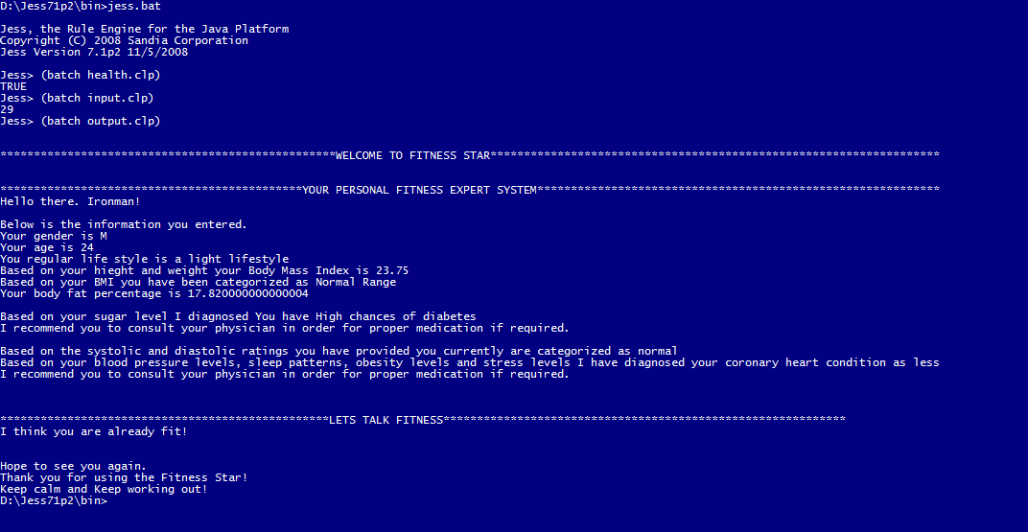

## Run #2

The contents of input.clp file:

(assert (person(personName Catwoman)(sex F)(activityType sedentary)(sugarLevel 100.6)(workoutType moderate)(age 24)(height 1.6256)(weight 40)(bloodPressureSystolic 125)(bloodPressureDiastolic 90)(currentSleepHours 5)(avgHR 125)))

(run)

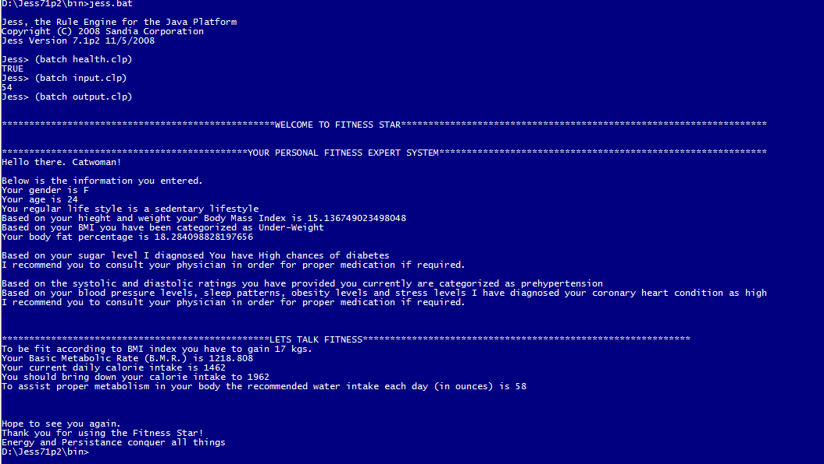

## Run #3

The contents of input.clp file:

(assert (person(personName Batman)(sex M)(activityType intense)(sugarLevel 120.0)(workoutType moderate)(age 24)(height 1.6256)(weight 90)(bloodPressureSystolic 140)(bloodPressureDiastolic 101)(currentSleepHours 9)(avgHR 100))) (run)

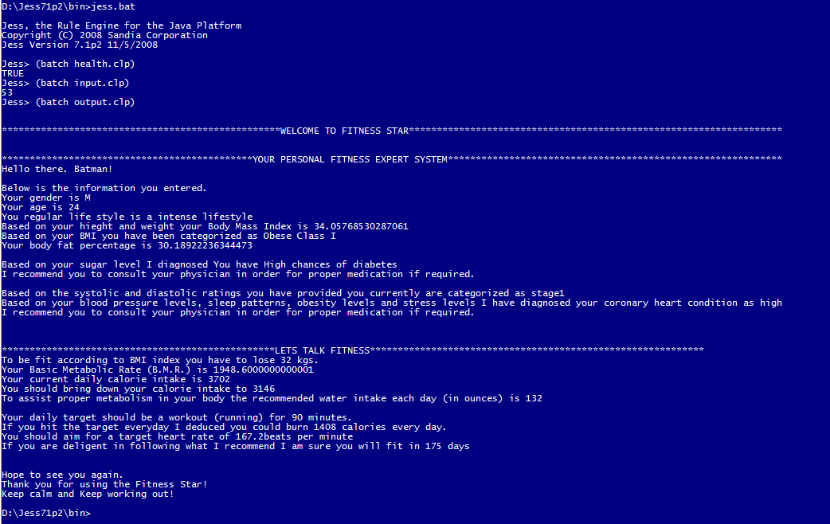

# Test cases:

Please use only one test case at a time in the input.clp file

(assert (person(personName Robin)(sex M)(activityType sedentary)(sugarLevel 65.6)(workoutType moderate)(age 24)(height 1.7272)(weight 76)(bloodPressureSystolic 125)(bloodPressureDiastolic 85)(currentSleepHours 8)(avgHR 125)))

(assert (person(personName Batman)(sex M)(activityType intense)(sugarLevel 120.0)(workoutType moderate)(age 24)(height 1.6256)(weight 90)(bloodPressureSystolic 140)(bloodPressureDiastolic 101)(currentSleepHours 9)(avgHR 100)))

(assert (person(personName Catwoman)(sex F)(activityType sedentary)(sugarLevel 100.6)(workoutType moderate)(age 24)(height 1.6256)(weight 40)(bloodPressureSystolic 125)(bloodPressureDiastolic 90)(currentSleepHours 5)(avgHR 125)))

(assert (person(personName Ironman)(sex M)(activityType light)(sugarLevel 100.6)(workoutType moderate)(age 24)(height 2.0)(weight 95)(bloodPressureSystolic 118)(bloodPressureDiastolic 81)(currentSleepHours 2)(avgHR 125)))